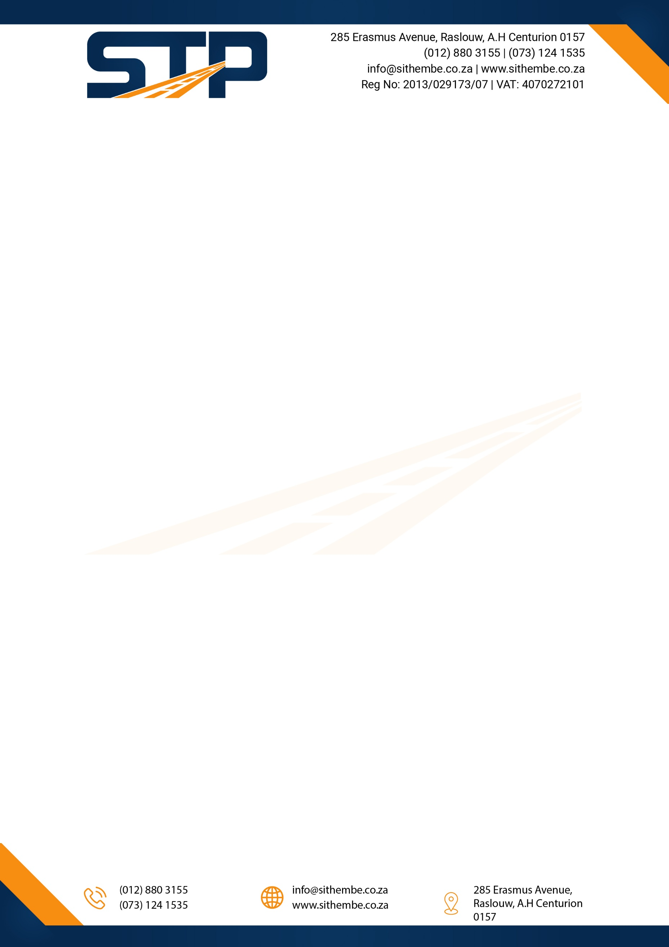

DELIVERY NOTE
:

FROM  SITHEMBE TRANSPORTATION AND PROJECTS PTY LTD | TO  City of Tshwane
CUSTOMER VAT NO: 4070272101
POSTAL ADDRESS: PHYSICAL ADDRESS:
285 Erasmus Avenue 285 Erasmus Avenue
Raslouw Raslouw
Centurion Centurion
0157 0157
Description Quantity
Portable Toilets 10 | Leeuwfontein Ext 32

Delivered by

Signed: ____________________________ Name: _______________________________

Date: ________________________________

Received in good order

Signed: ____________________________ Name: _______________________________

Date: ________________________________

